**Software Requirement Specification (SRS)**

For

**RedBus**

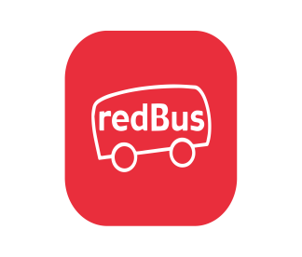

**Prepared by:**

**Potluri Jaya Prakash Rao – 160720733061**

**Rapolu Sumanth – 160720733064**

**Yen Reddy Adithya Vardhan Reddy – 160720733065**

**Methodist College of Engineering and Technology**

**To**

**Er. Sandeep Ravikanti**

**Assistant. Professor-CSE**

**Table of Contents:**

| Serial number | Figure | PAGE NUMBER |
| --- | --- | --- |
| 1 | **INTRODUCTION** | **III** |
| 1.1 | Purpose | III |
| 1.2 | Document Conventions | III |
| 1.3 | Intended Audience & Reading Suggestions | III |
| 1.4 | Project Scope | III |
| 1.5 | References | III |
| 2 | **Overall Description** | **IV-V** |
| 2.1 | Product Perspective | IV |
| 2.2 | Product Features | IV |
| 2.3 | User Classes & Characteristics | IV |
| 2.4 | Operating Environment | IV |
| 2.5 | Design & implementation Constraints | IV-V |
| 2.6 | User Documentation | V |
| 2.7 | Assumptions & Dependencies | V |
| 3 | **Specific Requirements** | **V** |
| 3.1 | Functional Requirements | V |
| 3.1.1 | Registration | V |
| 3.1.2 | Login | V |
| 3.1.3 | Authorization | V |
| 3.1.4 | Search | V |
| 3.1.5 | Booking | V |
| 3.1.6 | Payment | V |
| 3.1.7 | Logout | V |
| 3.1.8 | Ticket Generation | V |
| 4 | **Interface Requirements** | **VI** |
| 4.1 | Hardware Interface | VI |
| 4.2 | Software Interface | VI |
| 5 | **System Design Specification** | **VI-X** |
| 5.1 | Data Flow Diagram | VI |
| 5.1.1 | Level 0 Data Flow Diagram | VII |
| 5.1.2 | Level 1 Data Flow Diagram | VII |
| 5.2 | Class Diagram | VII-VIII |
| 5.3 | Use Case Diagram | VIII-X |
| 5.3.1 | * Use case diagram for Bus Booking | IX |
| 5.3.2 | * Use case diagram for Bus Tracking | IX |
| 5.3.3 | * Use case diagram for Customer Service | X |
| 6 | **Testing** | X-XI |

**1. INTRODUCTION**

This document is prepared in order to determine a software requirement specification for RedBus. RedBus is built as one of the ecommerce sites and will be very responsive to ticket booking and always keeps the latest offers and best routes in its online catalogue. The overview about the report is given, the purpose, scope, and an overall description of the Red Bus’s system is demonstrated. In addition to these, system features such as Searching, Booking, best route, boarding & drop selection and customer service functions are described.

**1.1 PURPOSE**

lThis document presents a detailed explanation of the objectives, features, user interface and application of RedBus in real life. It will also describe how the system will perform and under which it must operate. In this document it will also be shown the user interface. Both the stakeholders, users, and the developers of the system can benefit from this document.

**1.2 Document Conventions**

We will also use bold letters to emphasize main topics and for all the major functions of the system. We will use some acronyms through this document.

**1.3: Intended Audience and Document Overview:**

This project is a prototype for the online shopping system. This document is intended for different types of readers such as customers, stakeholder, system designer, system developer and tester. By reading this document a reader can learn and understand about what the project is implemented for and how it will present its basic ideas. This document has a sequential overview of the whole project so if a reader reads the document from top to bottom, he will get a clear idea about the project.

**1.4: Project Scope:**

The purpose of the online shopping system is to ease user shopping and to create a convenient and easy-to-use platform for customers, trying to book online bus, train etc. This study aims at studying client servicing and business development processes.

1. Finding out the strengths and weaknesses of the RedBus.
2. Finding the number of future purchases.
3. Finding the customer satisfaction and their means of awareness of RedBus.
4. Finding the position among the competitors.
5. Finding out the perception of customers about RedBus.
6. The main target is stronger supply chain and aggressive acquisitions.

**1.5: References:**

Software engineering standard committee of the IEEE computer society, IEEE recommended

practice for software requirements specification 1998

* www.wikipedia.com
* www.w3techs.com

**2. Overall Description**

**2.1 Product Perspective**

This software will help the user to connect to the bus agencies, through this system the agency owner can reach to other areas, helps to make the booking for those who are unable to go to the nearby agencies, it keeps record and payments details so, owner can make good decision, provides a great variety to the user.

**2.2 Product Features**

* Online booking via mobile application.
* Make the payment through various methods.
* Selecting the best routes.
* Boarding & drop selection.
* Vehicle type selection.

**2.3 User Classes and Characteristics**

There are five types of actors and one cooperating system

* CHARACTERISTICs: There are several users of this system.
* USER: With no any special training to operate the software. The user will have a username and password to make a booking, it includes user name, address, and phone number. This information may be used for keeping the records of the user for customer service-related data.
* AGENCIES: Will get booking/reservation from the user and reserve the seat on the passenger’s name.
* WISH MASTER: Gets information and books ticket from the selected bus/seat and generates a ticket with Passenger information.
* ADMIN: Who can make changes in the interface of the application. He or she is responsible for monitoring functions and procedures on the platform. Administrator is responsible to provide valid information of a booking to the concerned authority in case of any dispute between the customer and agencies or in case of exchange.

**2.4 Operating Environment**

Operating environment for the airline management system is as listed below.

* distributed database
* client/server system
* Operating system: Windows, Android, IOS
* database: SQL database
* platform: Python/CSS/HTML

**2.5: Design and Implementation Constraints:**

There are some constraints which are reducing the popularity of REDBUS:

• Slow speed of internet of user device, restaurant device or wish master in particular area.

• Online booking majorly decreases contact with the community.

• Sometimes users must face an unexpected lack of information in the booked seat.

• Slow speed of the application forces users to switch to another faster platform.

• Refunds can sometimes be complicated/delayed.

**2.6: User Documentation:**

Users can read documentation of applications or can make a contact to the customer service for any assistance.

1.Notifications

2.Contact us

3.User agreement

4.Make a payment

5.Submit account details

6.Payment security.

7.Privacy policy.

**2.7 Assumptions and Dependencies:**

* All the users, Agencies, bus-drivers are comfortable with the operating system.
* Not all the agencies, routes are connected to the services.
* Not all the agencies are available at all routes.
* If booking is cancelled automatic refund will be made.
* Software will never crash.
* The Internet is required to access software.

**3. SPECIFIC REQUIREMENTS**

**3.1: Functional specifications:**

**3.1.1: Registration:** If a customer wants to book the ticket, then he/she must be registered, an unregistered user cannot book the tickets.

**3.1.2: Login:** Customer logins to the system by entering a valid phone number and OTP.

**3.1.3: Authorisation:** The entered phone number and OTP are checked in the database and if it is valid then the user is allowed to login

**3.1.4: Search**: Searches can be made in order of type of vehicle, route, agencies etc

**3.1.5: Book:** If the customer wants to further proceed with the seat selection, he can press the buy tickets.

**3.1.6: Payment:** For Customers, there are many types of secure billings which will be prepaid as debit or credit card, redeem points, & EMI option is also available.

**3.1.7: Logout:** After the payment, the customer can be logged out of the app.

**3.1.8:** Ticket Generation: After booking for the tickets, the system will send one copy of ticket info to the user’s Email address and another one for the system database.

**4.Interface Requirements**

Various interfaces for the product would be

1. Login.
2. Search for the starting & destination.
3. Sort according to the user preferences.
4. If the customers select the seats & proceed, then another screen of payment will be opened.
5. After all transaction the system makes the selling report as portable document file (.pdf) and sent to the customer Email address

There are mainly 2 types of interfaces as such supported by this software system namely;

* Software Interface
* Hardware Interface

**Hardware Requirements:** In Windows or android-versions such as XP and 7 and more has Azure Disk Storage which helps in running the software Red Bus.

**Software Requirements:**

1. In apple iOS**:** It has an advanced mobile operating system with its easy-to-use interface containing azure data lake storage, VMware ESXi, Amazon Work-mail, VMware server which helps in using RedBus.

2.Server-side programming language: PHP used on a subdomain - a scripting language for creating websites.

3.Client-side programming language: JavaScript-JavaScript is a lightweight, object-oriented, cross-platform scripting language, often used within web pages.

4.Site elements: External CSS-External Cascading Style Sheets define style rules in a separate CSS file. Embedded CSS-Embedded Cascading Style Sheets define a set of style rules in a <style> element within a web page.

5.Markup Language: HTML5 is the fifth revision of the HTML standard.

**5.SYSTEM DESIGN AND IMPLEMENTATION**

**5.1 Data Flow Diagram**

**Data Flow Diagram Level-0:** The below DFD level-0 diagram gives us the overview of the online booking system in the Red Bus application.

**Data Flow Diagram Level-1** gives us the detailed information regarding the customer or user functions upon the process and the information regarding the process output is obtained to admin.

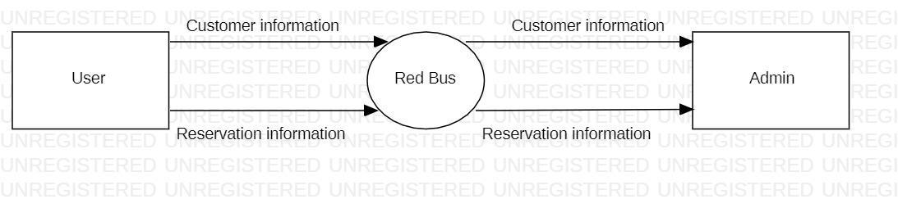

***5.1.1 Data Flow Diagram Level 0***

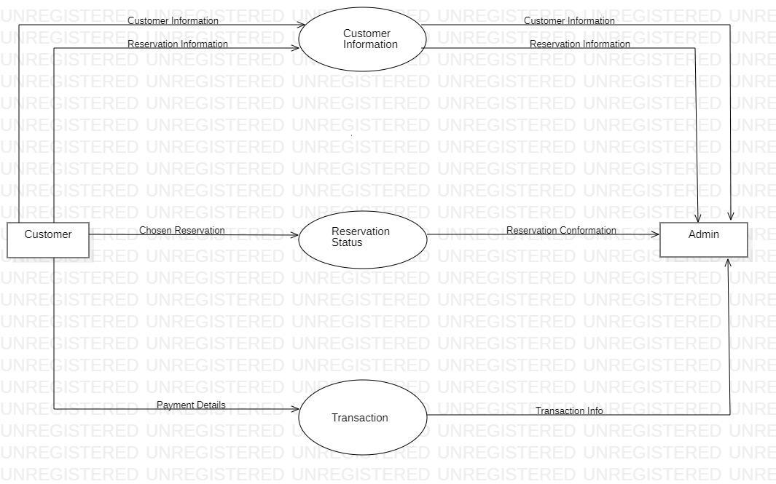

***5.1.2 Data Flow Diagram Level 1***

**5.2 Class Diagram**

A class diagram describes the structure of the Online booking system (Red Bus) by its classes of Account, Account management and Customer services etc and their attributes and operations along with the relation between each class.

The structural representation of Red Bus is explained with following classes:

* Account: (a) New Account (b) Registered Account
* Account Management
* Tracking
* Customer Service
* Booking
* Payment

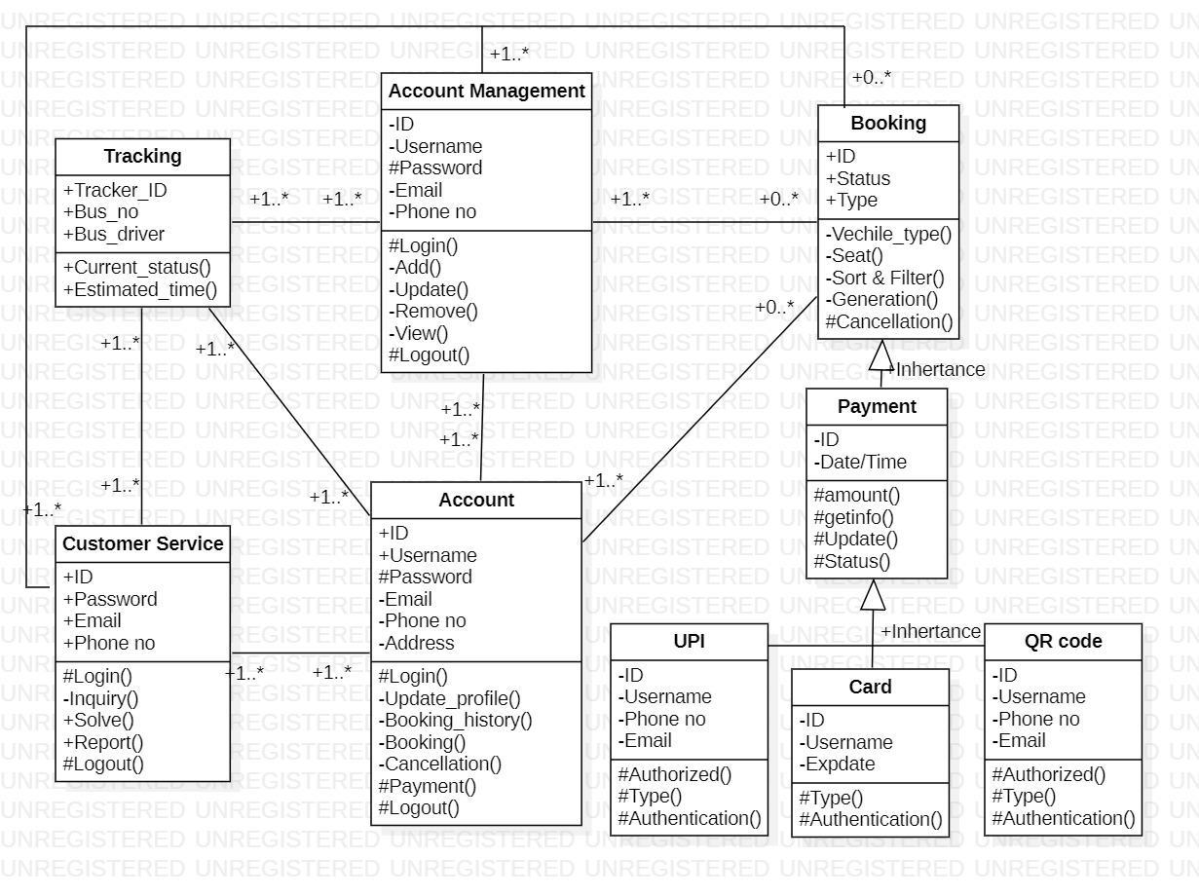

***5.2 Class diagram***

**5.3 Use Case Diagram**

A use case diagram can summarize the details of your system's users (also known as actors) and their interactions with the system. To build one, you will use a set of specialized symbols and connectors.

**5.3.1 Use case diagram for Bus Booking**: The Use case diagram represents the functional requirements for booking a bus ticket in the red bus application. These are the basic flow of scenarios for booking a ticket in the Red Bus.

**5.3.2 Use Case diagram for bus tracking:**The Use case diagram represents the functional requirements for the bus tracking in the red bus application. These are the basic flow of events for tracking a bus in the red bus applications.

**5.3.3 Use Case diagram for customer service:**The Use case diagram represents the functional requirements for the customer service in the red bus application. These are the basic flow of events for tracking a bus in the red bus applications.

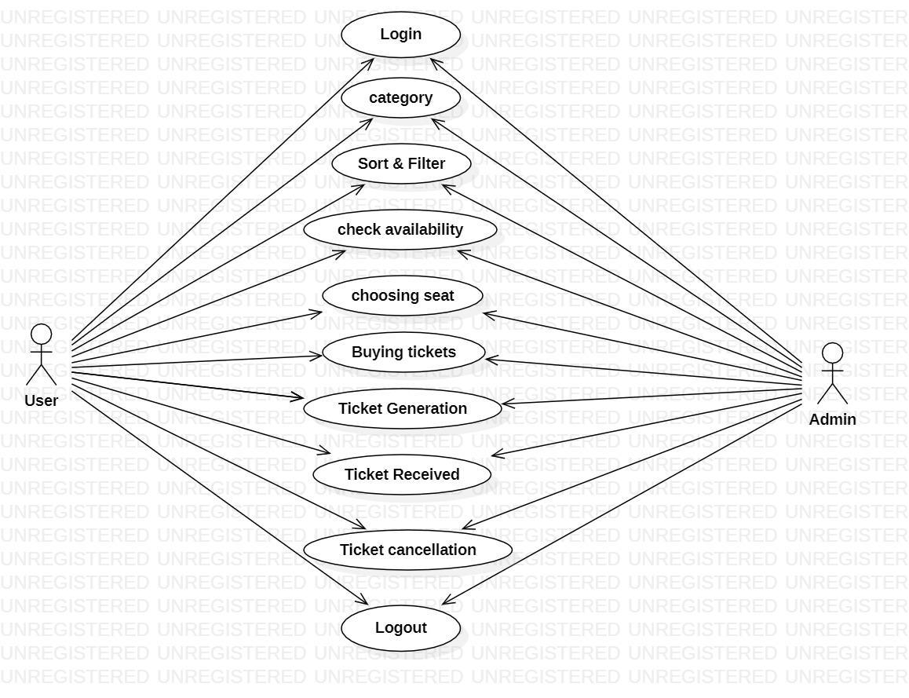

***5.3.1 Use Case diagram for Bus Booking***

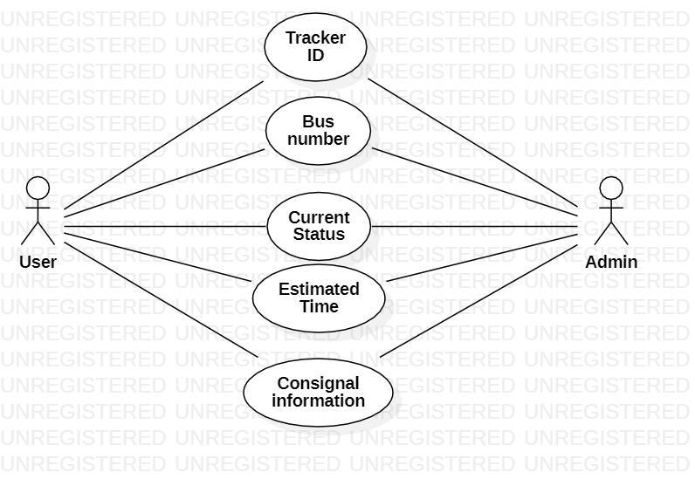

***5.3.2 Use Case diagram for bus tracking***

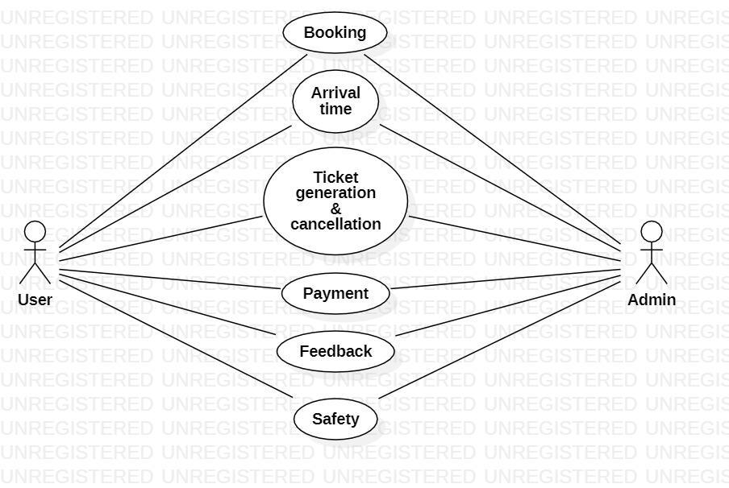

***5.3.3 Use Case diagram for customer service***

**6 Testing**

The parameters of the test are: Test Case ID, Test Scenario, Test Case Description, Test Steps, Prerequisite, Test Data, Expected Result, Test Parameters, Actual Result etc.

| **Test case ID:** Test_01 |
| --- |
| **Test priority (Low/Medium/High):** Medium |
| **Medium Module name:** login |
| **Test title:** verify login with valid username and password |
| **Precondition:** User has invalid username and password |

***6.1 Test Case Parameter***

| **Test Scenario ID** | **Test Scenario** | **Test Case ID** | **Test Steps** | **Input** | **Expected Result** | **Actual Result** | **Result/**  **Status** |
| --- | --- | --- | --- | --- | --- | --- | --- |
| **Register** | | | | | | | |
| TS-1 | Check register application | TC-1.1 | Click Sign in | Valid Phone & OTP | Registered page will be displayed | As Expected, | Pass/Successful |
| Tc-1.2 | Click Sign in | In Valid Phone & OTP | Registered page is not displayed | Show  try  again | Fail/Unsuccessful |
| **Login** | | | | | | | |
| TS-2 | Check Login | Tc-2.1 | Click Login | Registered Phone & Valid OTP | Login Access will be provided | As expected, | Pass/Successful |
| Tc-2.1 | Click Login | Registered Phone & In-Valid OTP | Will not  verify us  OTP | As  Expected | Fail/Unsuccessful |
| Tc-2.1 | Click Login | Unregistered Phone no | Will not verify the Phone no | As Expected, | Fail/ Unsuccessful |
| Tc-2.1 | Click Login | Unregistered Phone & In-Valid OTP | Will not verify the Phone no | As Expected, | Fail/ Unsuccessful |

***6.2 Test Case for Register and Login***

**RESULT:** The Myntra system was designed and implemented successfully***.***

**C. List of abbreviations**

| **Serial Number** | **Abbreviation** | **Meaning** |
| --- | --- | --- |
| **1** | App | Application |
| **2** | UI | User Interface |
| **3** | DFD | Data Flow Diagram |
| **4** | UML | Unified Modeling Language |
| **5** | UPI | Unified Payments Interface |
| **6** | AWS | Amazon Web Service |
| **7** | SaaS | Software as a Service |
| **8** | ID | Identity |
| **9** | OTP | One Time Password |
| **10** | TS | Test Scenario |
| **11** | TC | Test Case |
| **12** | IOS | iPhone Operating System |
| **13** | DB | Data Base |
| **14** | PHP | Hypertext Preprocessor |
| **15** | SQL | Structured Query Language |
| **16** | CSS | Cascading style sheet |
| **17** | HTML | Hypertext Markup Language |
| **18** | JS | Java Script |
| **19** | ASP | Active Server Pages |
| **20** | .net | Network |

**QR CODE**